**Power BI**

**Project Report**



**[PROJECT TITLE]**

**SUBMITTED TO: Ms.Leesha Patlaan**

**SUBMITTED BY: Avanish Kumar Yadav**

**ACKNOWLEDGEMENT**

I am writing to express my profound gratitude to Idemia India Foundation and Lok Bharti Education Society for their invaluable contributions to the completion of my project entitled [Project Title].

I would like to extend my sincere thanks to all the staff members of the Idemia India Foundation. Their guidance, advice, and suggestions were instrumental in navigating the complexities of the project and ensuring its successful completion.

In particular, I would like to express my heartfelt appreciation to Mr. Mukesh Kumar Mandal (Center Manager), for his unwavering guidance and support throughout the training period. His mentorship played a pivotal role in shaping my understanding and approach to the project.

I am also immensely grateful to our mentor, Ms. Leesha Patlaan (Data Analysis Trainer), for her dedicated time and efforts. Her insightful advice and suggestions significantly contributed to the refinement and enhancement of the project's outcomes.

Furthermore, I want to acknowledge that this project was completed solely by me, and no external assistance was involved in its execution.

SIGNATURE OF PROJECT GUIDE

**CONTENTS**

1. Project description

2. Problem statement

Aim(solution)

3. Requirement analysis

Software

Hardware

4. Dataset

Sources

5. Output screenshots

6. Conclusion(Insights)

7. Future scope

1. **Project description**  
   IT expenditure refers to the financial resources allocated by an organization for acquiring, managing, and maintaining information technology assets and services. It encompasses expenses related to hardware, software, networking infrastructure, personnel, maintenance, training, and other IT-related costs. Effective management of IT expenditure is essential for optimizing investments, enhancing operational efficiency, and supporting business objectives.
2. **Problem statement:-**

IT expenditure within our organization lacks clear oversight and strategic planning, leading to inefficiencies, budget overruns, and suboptimal utilization of resources. Despite the significant investment in information technology, there is a lack of alignment between IT spending and business goal.

**AIM(Solution):-** The aim is to implement a structured approach to IT expenditure management, incorporating clear governance mechanisms, strategic planning processes, and performance metrics. This involves centralizing budgetary control, establishing accountability measures, and aligning spending with business priorities. By optimizing resource allocation and enhancing transparency, the solution aims to drive efficiency, improve financial performance, and maximize the value derived from IT investments.

1. **Requirement analysis**

**Software**

**Dashboard Creation Tool:** Choose Power BI for its robust features and seamless data integration.

**Data Integration Tools**: Assess additional tools for compatibility with Power BI. **Database Management System (DBMS):** Ensure compatibility with Power BI for data storage.

**Web Server:** Determine compatibility with Power BI Service for online deployment.

**Operating System**: Select an OS compatible with Power BI Desktop and Service.

Hardware :-

**Sufficient Computing Resources:** Determine CPU, RAM, and storage for optimal Power BI Desktop performance.

**Compatibility:** Ensure hardware meets Power BI Desktop requirements.

**Hosting Infrastructure:** Evaluate on-premises or cloud-based hosting compatible with Power BI Service.

**Network Infrastructure:** Ensure sufficient bandwidth for data transfer between Power BI components.

**Data Storage:** Assess storage requirements compatible with Power BI data sources (local or cloud storage).

1. **Dataset**

**Sources :-**

**Actual Data:-**

**Financial Records:** Procurement records, expense reports, and accounting data.

**Inventory Systems:** Hardware and software inventory records.

**Business Area:** Organizational Structure data.

**Cost Element:** Financial Systems: General ledger data.

**Country:** Geographic Data sources.

**Date:** Timestamps.

**Forecast:** Budget Allocation Data.

**IT Area and IT Sub Area**: Categorization Data. Plan, Budget Plans. **Reason:** Annotation Data.

1. **Output screenshots:-**

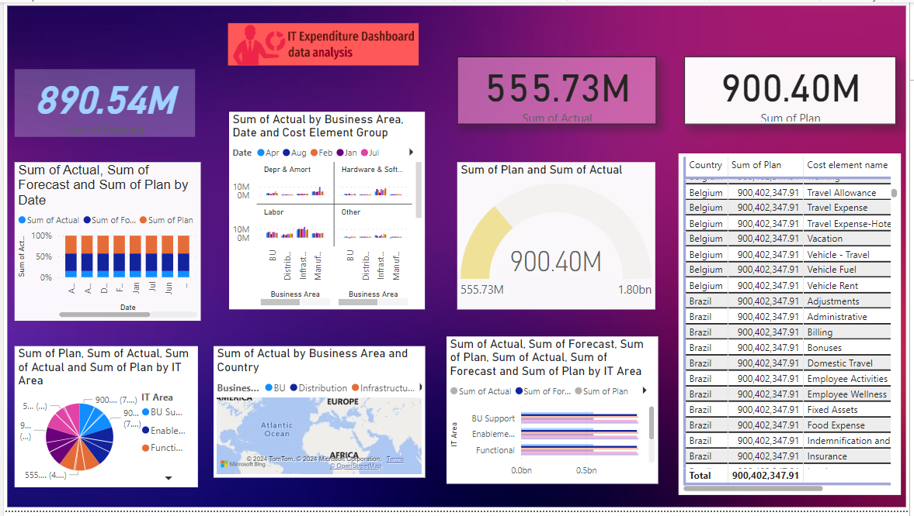

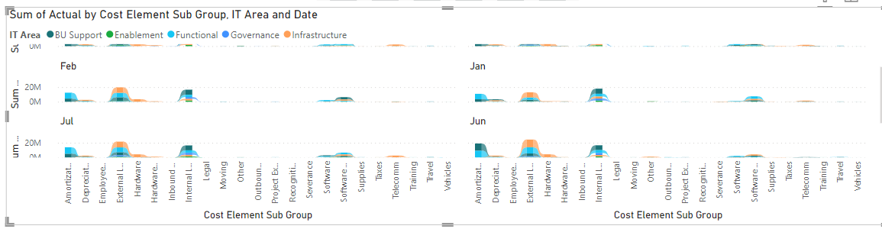

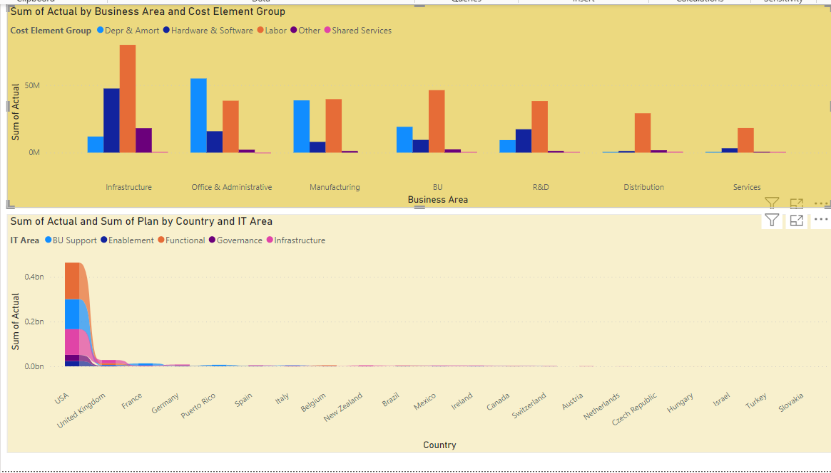

**Conclusion(Insights):-**

Effective Management: Structured IT expenditure management is essential for optimizing investments and supporting business goals.

Alignment: Aligning IT spending with business objectives prevents inefficiencies and budget overruns.

Power BI: Utilizing Power BI offers robust data integration and visualization capabilities.

Hardware Considerations: Adequate computing resources and compatible hosting infrastructure ensure optimal performance.

Data Sources: Accessing actual expenditure data and categorizing information provides comprehensive insights.

Forecasting: Forecasting future expenditures aids in budget planning and decision-making.

Integration: Integrating diverse datasets facilitates meaningful analysis and visualization.

Accountability: Incorporating reasons for expenditures enhances transparency and governance

***Future scope:-***

**Advanced Analytics**: Utilize predictive modeling and machine learning to forecast future IT expenditures accurately based on historical data and market trends.

**Real-time Monitoring:** Develop capabilities for tracking IT expenditure in real-time, facilitating proactive decision-making and cost control measures.

**Enhanced Governance:** Strengthen governance by automating workflows and approval processes for IT expenditure requests, ensuring compliance with budgetary guidelines.

**Integration with Financial Systems:** Integrate IT expenditure management with financial systems to streamline data exchange and reporting, enhancing visibility and accountability.

**Cost Optimization:** Identify inefficiencies and implement cost-saving measures such as vendor negotiations and software license optimization.

**Benchmarking and Comparative Analysis:** Compare IT expenditure against industry standards to identify areas for improvement and strategic investment.

**User Training and Adoption:** Provide comprehensive training to users for effective utilization of expenditure management tools, maximizing ROI.